

Items highlighted in yellow are tasks for you to complete
Items in Blue are help tips

MWP 127 Create a 3 Fold brochure

TITLE: Brochure


Years:

Class: Information Technology Technology

Teacher: Mr Faulks

Topic: A Three (3) Fold Brochure

Aspects:

Timeline: Lessons

Due:

Task Brief: Your favourite band is running a competition. They want to find the fan that can produce the best brochure to promote their new CD. You are to use any software package (i.e. Microsoft Word, Photoshop, Paintshop Pro, Publisher etc.) to produce that brochure.

The brochure must:

- Be on A4 paper and a three fold
(Will have three inside pages and three outside pages)
- Contain images of the band
- Have a profile of each band member
- Promote the new album
- Promote two previous albums
- Advertise band merchandise
- Have an order form for that merchandise

Find information about any band (make up a band if you wish) from your own resources or from the Internet, obtain pictures and text information about the band suitable to put onto your brochure.

Obtain some items for merchandising i.e. T-Shirts, Pens, etc. create an order form to suit your merchansise items.

Task One: A Promotional Brochure

Brochures

Outside Pages  Page 1 (Microsoft Publisher) | Inside Pages  Page 2 (Microsoft Publisher)

Back page
Front page
Page 4
Page 1
Page 3
Page 2

Brochures

Front page
This page needs to capture people’s attention. The potential reader will see it from several meters away and decide whether or not they will walk up to it, pick it up and have a read. A person needs to be able to read the title from a distance.

Once the person picks up the brochure they will decide to read it if they it has interesting teaser headings. That is, if the headings spur on his/ her curiosity or interest.

Page 1, 2 & 3
The most important information is included here on the inside panels. Perhaps you might like to use these panels to introduce your organisation and to describe specific products or services. This text should be brief and should entice the reader to want to know more about a product or service.
You should use secondary headings to organize your text and to make it more scannable for the reader. Page 3 is typically good for an order form.

Page 4
This is a good place to briefly, but effectively, summarise the products or services that you offer.

Back page
This is the last page the reader looks at and your last chance to make an impression. Decide what you want the reader to remember. Perhaps you want the reader to take a certain action like contacting the company.

Go to page set up and make your page in Landscape

To assist you I have created some band members, see (Y10 IT Graphics Files) you need to combine the pictures to form a group picture of the band, you can also use the pictures for background stories about the band members for the brochure.

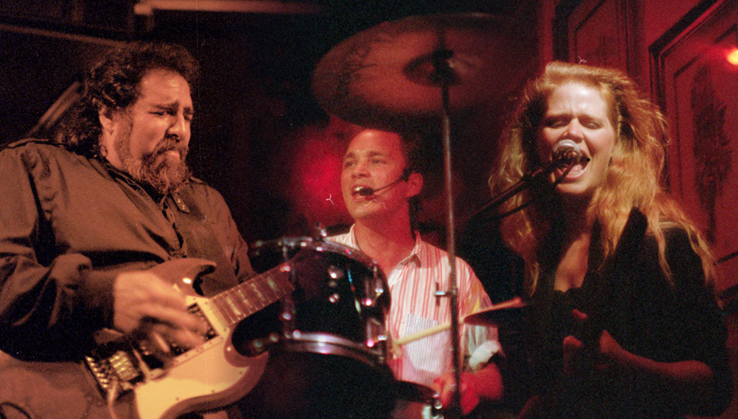

Submission Requirements Checklist

Demonstrated

Outcome 1 – You need to provide sketches, thumbnails, brainstorms, drafts, a time plan and analytical discussions regarding how you used the following process:
- Investigating – Searching, making enquiries, listening, observing, collecting samples, examining other peoples products, brainstorming and considering alternatives.
- Devising – Coming up with various ways of completing a task and experimenting with the alternatives.
- Producing – Demonstrate what you have done and why.
- Evaluating – Reflect on what you are doing and what you have done.

Outcomes:
Outcome | Description of Outcome
1 | Technology Process – Uses the technology process to solve a range of problems found in the business environment.
2 | Information – Collects, organises and uses data for the presentation and communication of information.
3 | Industry Standards – Applies and describes the elements and principles of design in accordance with accepted industry standards. Students apply organisational, operational, and manipulative skills appropriate to using, developing and adapting technologies.
4 | Innovation – Uses innovative techniques to attract an audience and to solve design problems.
6 | Behaviour – Students behave and speak in an appropriate manner in the classroom. They listen to and obey teacher’s instructions. They ask politely for assistance when needed. Students work on assigned tasks and use equipment as instructed. Safe practices are used at all times.
8 | Organisation – Students organise their resources and their time. They arrive at classes on time and submit assigned work when due. Students have their books and equipment with them when needed.

Submission Requirements Checklist

Demonstrated

Outcome 1 – You need to provide sketches, thumbnails, brainstorms, drafts, a time plan and analytical discussions regarding how you used the following process:
- Investigating – Searching, making enquiries, listening, observing, collecting samples, examining other peoples products, brainstorming and considering alternatives.
- Devising – Coming up with various ways of completing a task and experimenting with the alternatives.
- Producing – Demonstrate what you have done and why.
- Evaluating – Reflect on what you are doing and what you have done.

Outcome 2 – You need to:
- Collect information from a variety of sources
- Organise the collected information in a clear and logical sequence
- Combine different pieces of information into a unified whole
- Present relevant information in a clear and coherent way
- Produce information relevant to a specified audience
- Demonstrate correct grammar and spelling.

Submission Requirements Checklist cont… | Demonstrated
Outcome 3 – You need to:
- Collect relevant samples of accepted industry standards
- Explain how they used the samples to produce their own work
- Demonstrate creative use and manipulation of graphics
- Apply effective skills of design (Contrast, repetition, alignment, proximity & type)
- Create and manipulate graphics from a variety of sources
- Demonstrates effective file management.

Outcome 4 – You need to:
- Produce original ideas and work samples
- Independently explore and document alternative techniques to solve a design problem
- Independently or collaboratively learn and apply new techniques (Techniques which have not been covered by the teacher)

Outcome 6 – You need to:
- Speak appropriately to the teacher
- Speak appropriately to your peers in the classroom
- Ask for assistance when you need it
- Work on the task at hand without becoming distracted
- Use the equipment correctly

Outcome 8 – You need to:
- Complete your work by the due date
- Remember your login and password
- Arrive to class on time
- Develop and maintain a clear and appropriate subject directory, subdirectories and files
- Save your work in the correct directory and subdirectory

